Setting up users and roles in the domain.
- Start Weblogic Server.
- Login to Weblogic Server console as admin user.
- Add new users.
  - Click “Security Realms”.
  - In the Realms table click “myrealm”.
  - Click “Lock & Edit” button. (if this is not visible click Preferences and uncheck the “Automatically Aquire Lock and Activate Changes” box, then click Save.
  - Change the “Security Model Default” value to “Custom Roles”.
  - Click the “Save” button.
  - Click “Activate Changes”.
  - Click the “Users and Groups” tab.
  - Click the “Users” tab.
  - Click the “New” button.
  - Create new user “monitor” with password “testuser” and click OK.
    - Fill in the “Name”, “Description”, and “Password” fields for the new users. Leave Provider as default value. Click OK to save the new user.
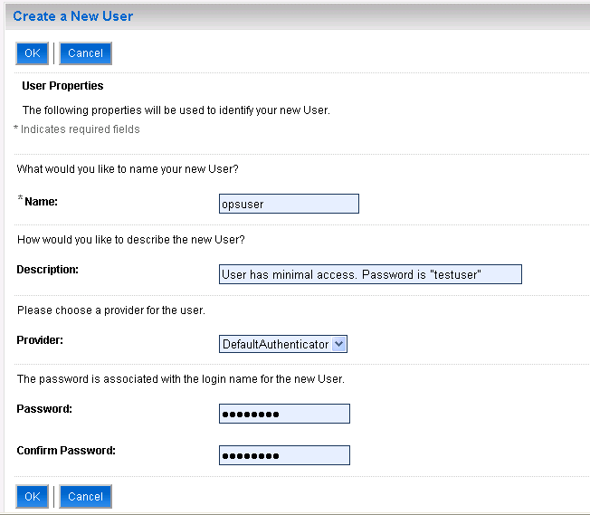
    - Repeat this to create all of the users in this list:
USERNAME | PASSWORD | DESCRIPTION
eccuser | testuser | User has ECC access.
monitor | testuser | User has SOM_SUPP access.
opsadmin | testuser | User has admin access.
opsuser | testuser | User has minimal access.
noaccessuser | testuser | User does not have access.

- Add new Groups.
  - Click “Security Realms”.
  - In the Realms table click “myrealm”.
  - Click the “Users and Groups” tab.
  - Click the “Groups” tab.
  - Add the name “OpsUsers”. Leave Provider as default value. Click OK to save the new group.
    - Repeat this to add all of the following groups (Note that Monitors group may already exist by default):
ROLE NAME
Monitors
OpsUsers
OpsAdmins
ECCUsers

- Add the new users to the new groups.
  - Click “Security Realms”.
  - In the Realms table click “myrealm”.
  - Click the “Users and Groups” tab.
  - Click the “Users” tab.
  - Add “monitor” user to the “Monitors” group.
    - Click the new “monitor” user.
    - Click the “Groups” tab.
    - Locate and highlight the “Monitors” group in the list on the left and click the right pointing arrow to move it to the empty list on the right.
    - Click “Save”.
  - Repeat step 5.1 through 5.5 to assign each of the following users to the correct group:
USERNAME | GROUP NAME
monitor | Monitors
opsuser | OpsUsers
opsadmin | OpsAdmins
eccuser | ECCUsers
noaccessuser | (do not assign this user to a group)

- Add new Roles.
Note that group names end with the letter s and role names will not.
  - Click “Security Realms”.
  - In the Realms table click “myrealm”.
  - Click “Roles and Policies” tab.
  - Expand “Global Roles”.
  - Click on “Roles”.
  - Click the “New” button.
  - Add the name “OpsUser”. Leave Provider Name as default value. Click OK to save the new role.
    - Repeat this to add all of the following roles (Note that Monitor role may already exist by default):
ROLE NAME
Monitor
OpsUser
OpsAdmin
ECCUser

- Give the newly created groups access to the new roles.
Note that group names end with the letter s and role names do not.
  - Click “Security Realms”.
  - In the Realms table click “myrealm”.
  - Click “Roles and Policies” tab.
  - Expand “Global Roles”.
  - Click on “Roles” (Note: If the resulting list does not show all of the roles created, click the “Customize this table” link and increase the “Number of rows displayed per page” to 25 and click “Apply”.)
  - Click on the “OpsUser” role.
  - Click the “Add Conditions” button.
  - Select “Group” in the “Predicate List” dropdown list and click “Next”.
  - Enter the value “OpsUsers” group name in the “Group Argument Name” field and click Add. Click “Finish”.
    - This should be the result:
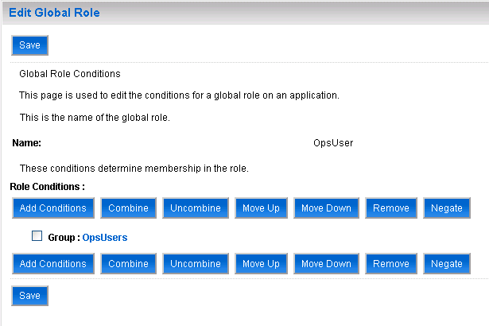
  - Click the “Save” button.
  - Repeate steps 7.1 through 7.10 to assign each of the following groups to the correct role (Note that the “Monitors” group may already be assigned to the “Monitor” role by default):
ROLE NAME | GROUP NAME
Monitor | Monitors
OpsUser | OpsUsers
OpsAdmin | OpsAdmins
ECCUser | ECCUsers

- Restart Weblogic server.

Add startup environment variable.
- Open the bin folder in the domain root directory.
example:
C:\bea\user_projects\domains\sdp-opsui\bin
- Edit the setDomainEnv.cmd script file.
- Append the following script to the end of the file then save and close (Note: if running on Linux then make the equivalent changes with appropriate syntax to the setDomainEnv.sh file instead):
@CUSTOM
set JAVA_OPTIONS=%JAVA_OPTIONS% -Dsdp.OpsUI.deploymentEnvironment=devtest_a

- Restart Weblogic server.

Configure data sources.
- Start Weblogic Server.
- Login to Weblogic Server console as admin user.
- Click “Lock & Edit” button. (if this is not visible click Preferences and uncheck the “Automatically Aquire Lock and Activate Changes” box, then click Save.
- Click “Data Sources”.
- Click the “New” button.
- Enter the name “som.sdp.datasource”
- Enter JNDI Name “som.sdp.datasource”
- Select “Oracle” in the Database Type dropdown list.
- Select “*Oracle’s Driver (Thin)…” in the Database Driver dropdown list.
- Click Next.
- Click Next.
- Enter the following details and click Next:
FIELD | VALUE
Database Name | od01g4db02
Host Name | dlocdb0402.na.bestbuy.com
Port | 21640
Database User Name | som_sdp_onl01
Password (and confirm) | (not listed here for security)

- Click Finish.
- Click on the new “som.sdp.datasource” data source.
- Click the “Targets” tab.
- Check the box in the Servers table and click Save.
- Repeat these steps to add a second data source “som.kcb.datasource”. Use all of the same configuration except the datasource name and JNDI name should be “som.sdp.datasource” and the Database User Name should be “cnf_tpa_onl01”.
- Click “Activate Changes”.
- Restart Weblogic server.

Configure SSL settings.
- Start Weblogic Server.
- Login to Weblogic Server console as admin user.
- Click “Lock & Edit” button. (if this is not visible click Preferences and uncheck the “Automatically Aquire Lock and Activate Changes” box, then click Save.
- Click “Environments”.
- Click “Servers”.
- Click “AdminServer(admin)”
- Check the “SSL Listen Port Enabled” checkbox.
- Click “Save” button.
- Click “Activate Changes” button.
- Restart Weblogic server.

Configuration Files.
- Open the domain root directory.
example:
C:\bea\user_projects\domains\sdp-opsui
- Create new folder “sdp-config”.
- Add latest version of sdp-config.properties file to the new sdp-config folder.
- In the sdp-config folder create a new folder “log4j”.
- Add latest version of log4j-opsui.properties file to the new log4j folder.
- Restart Weblogic server.

Deploy sdp-ui.war
- Open the sdp-ui project
- Open the local-build.properties file and set the “weblogic.home” property to the Weblogic home directory on your local PC.
- Set the DEPLOY.username and DEPLOY.password properties to match your admin WL user.
- Execute the local-build.xml ant file.
- Enter the following url in a web browser to validate deployment: https://127.0.0.1:7002/SDPUI

Issues encountered
If any issues are encountered during this process and a solution or workaround is found please update this document so that future developers can avoid these problems.

- Ross Stockman 11/2011

